To Contributors of Articles

In order to introduce the contributors of articles in the Journal of Disaster Research, published by our company, properly to its readers, each contributor is asked to send in the photo and personal data, as indicated below. These photos and personal data are considered particularly useful at international conferences where the article contributors and readers may get together. Your cooperation is greatly appreciated.
Sample of personal data

Name:
Takao Kakizaki
Affiliation:
Supervisor, Senior Research Engineer, NTT Human Interface Laboratories

Address:
3-9-11 Midori-cho, Musashino, Tokyo 180, Japan
Brief Career:
1979 Joined Nippon Telegraph and Telephone Corp.
1987- Visiting Scientist, Massachusetts Institute of Technology
1989- NTT Human Interface Lab.
Selected Publications:
• “Modeling the Special Dynamics of Robotic Manipulators with Flexible Links and Joint Clearances,” ASME Journal of Mechanical Design, Vol.115, pp. 839-847, Dec., 1993.
Academic Societies & Scientific Organizations:
• American Society of Mechanical Engineers (ASME)
• Japan Society of Mechanical Engineers (JSME)
• Robotics Society of Japan (RSJ)
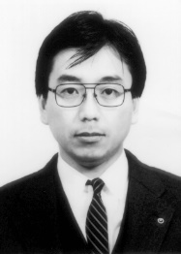

Please write your researcher number if you have.
ORCID iD
e-Rad researcher number

Name: | photo
Affiliation:
Address:
Brief Career:
Selected Publications:
Academic Societies & Scientific Organizations:

