To Contributors of Articles

In order to introduce the contributors of articles in the International Journal of Automation Technology, published by our company, properly to its readers, each contributor is asked to send in his photo and personal data, as an example below indicates. These photos and personal data are considered particularly useful at international conferences where the article contributors and readers may get together. Your cooperation is greatly appreciated.
Sample of personal data

Name:
Takao Kakizaki
Affiliation:
Supervisor, Senior Research Engineer, NTT Human Interface Laboratories

Address:
3-9-11 Midori-cho, Musashino, Tokyo 180, Japan
Brief Biographical History:
1979- Joined Nippon Telegraph and Telephone Corp.
1987- Visiting Scientist, Massachusetts Institute of Technology
1989- NTT Human Interface Las.
Main Works:
• “Modeling the Special Dynamics of Robotic Manipulators with Flexible Links and Joint Clearances,” ASME Journal of Mechanical Design, Vol.115, pp. 839-847, Dec., 1993.
Membership in Academic Societies:
• The American Society of Mechanical Engineers (ASME)
• The Japan Society of Mechanical Engineers (JSME)
• The Robotics Society of Japan (RSJ)
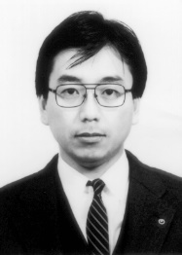

Please write your researcher number if you have.
ORCID iD
e-Rad researcher number

Name: | photo
Affiliation:
Address:
Brief Biographical History:
Main Works:
Membership in Academic Societies:

